**A**

**PROJECT REPORT**

**ON**

**“BANKING SYSTEM”**

**SUBMITTED BY: Tanuja Dhanraj Gaikwad (2124UCEF1040)**

SUBJECT:

**C++ PROGRAMMING**

Under the guidance of

**Miss. Ishwari Tirse**



**Department of Computer Science and Engineering**

**Sanjivani Rural Education Society’s**

**SANJIVANI UNIVERSITY**

KOPARGAON - 423603, DIST : AHEMDNAGAR

2024-2025

**INDEX**

|  |  |  |
| --- | --- | --- |
| **SR.**  **NO** | **CONTENT** | **PAGE NO.** |
| **1.** | **INTRODUCTION** | **3** |
| **2.** | **CODE** | **8** |
| **3.** | **OUTPUT** | **4** |
| **4.** | **CONCLUSION** | **16** |

# **INTRODUCTION**

# **A banking system is a classic example to demonstrate OOP concepts, where different banking operations like deposits, withdrawals, and account management can be encapsulated into classes.**

# 

**CODE**

#include <iostream>

#include <fstream>

#include <cstdlib>

#include <vector>

#include<map>

using namespace std;

#define MIN_BALANCE 500

class InsufficientFunds

{

};

class Account

{

private:

long accountNumber;

string firstName;

string lastName;

float balance;

static long

NextAccountNumber;

public:

Account()

{

}

Account(string fname, string lname, float balance);

long getAccNo()

{

return accountNumber;

}

string getFirstName()

{

return firstName;

}

string getLastName()

{

return lastName;

}

float getBalance()

{

return balance;

}

void Deposit (float amount);

void Withdraw (float amount);

static void

setLastAccountNumber (long accountNumber);

static long

getLastAccountNumber();

friend ofstream & operator << (ofstream & ofs, Account & acc);

friend ifstream & operator >> (ifstream & ifs, Account & acc);

friend ostream & operator << (ostream & os, Account & acc);

};

long Account::NextAccountNumber = 0;

class Bank

{

private:

map < long, Account > accounts;

public:

Bank();

Account OpenAccount(string fname, string lname, float balance);

Account BalanceEnquiry(long accountNumber);

Account Deposit(long accountNumber, float amount);

Account Withdraw(long accountNumber, float amount);

void CloseAccount(long accountNumber);

void ShowAllAccounts();

~Bank();

};

int main()

{

Bank b;

Account acc;

int choice;

string fname, lname;

long accountNumber;

float balance;

float amount;

cout << "Banking System" << endl;

do

{

cout << "\n\tSelect one option below:";

cout << "\n\t1 Open an Account";

cout << "\n\t2 Balance Enquiry";

cout << "\n\t3 Deposit";

cout << "\n\t4 Withdrawal";

cout << "\n\t5 Close an Account";

cout << "\n\t6 Show All Accounts";

cout << "\n\t7 Quit";

cout << "\nEnter your choice: ";

cin >> choice;

switch (choice)

{

case 1:

cout << "Enter First Name: ";

cin >> fname;

cout << "Enter Last Name: ";

cin >> lname;

cout << "Enter initil Balance: ";

cin >> balance;

acc = b.OpenAccount (fname, lname, balance);

cout << endl << "Congradulation Account is Created" << endl;

cout << acc;

break;

case 2:

cout << "Enter Account Number:";

cin >> accountNumber;

acc = b.BalanceEnquiry (accountNumber);

cout << endl << "Your Account Details" << endl;

cout << acc;

break;

case 3:

cout << "Enter Account Number:";

cin >> accountNumber;

cout << "Enter Balance:";

cin >> amount;

acc = b.Deposit (accountNumber, amount);

cout << endl << "Amount is Deposited" << endl;

cout << acc;

break;

case 4:

cout << "Enter Account Number:";

cin >> accountNumber;

cout << "Enter Balance:";

cin >> amount;

acc = b.Withdraw (accountNumber, amount);

cout << endl << "Amount Withdrawn" << endl;

cout << acc;

break;

case 5:

cout << "Enter Account Number:";

cin >> accountNumber;

b.CloseAccount (accountNumber);

cout << endl << "Account is Closed" << endl;

cout << acc;

case 6:

b.ShowAllAccounts ();

break;

case 7:

break;

default:

cout << "\nEnter corret choice";

exit (0);

}

}

while (choice != 7);

return 0;

}

Account::Account (string fname, string lname, float balance)

{

NextAccountNumber++;

accountNumber = NextAccountNumber;

firstName = fname;

lastName = lname;

this->balance = balance;

}

void Account::Deposit (float amount)

{

balance += amount;

}

void Account::Withdraw (float amount)

{

if (balance - amount < MIN_BALANCE)

throw InsufficientFunds ();

balance -= amount;

}

void Account::setLastAccountNumber (long accountNumber)

{

NextAccountNumber = accountNumber;

}

long Account::getLastAccountNumber ()

{

return NextAccountNumber;

}

ofstream & operator << (ofstream & ofs, Account & acc)

{

ofs << acc.accountNumber << endl;

ofs << acc.firstName << endl;

ofs << acc.lastName << endl;

ofs << acc.balance << endl;

return ofs;

}

ifstream & operator >> (ifstream & ifs, Account & acc)

{

ifs >> acc.accountNumber;

ifs >> acc.firstName;

ifs >> acc.lastName;

ifs >> acc.balance;

return ifs;

}

ostream & operator << (ostream & os, Account & acc)

{

os << "First Name:" << acc.getFirstName () << endl;

os << "Last Name:" << acc.getLastName () << endl;

os << "Account Number:" << acc.getAccNo () << endl;

os << "Balance:" << acc.getBalance () << endl;

return os;

}

Bank::Bank ()

{

Account account;

ifstream infile;

infile.open ("Bank.data");

if (!infile)

{

//cout<<"Error in Opening! File Not Found!!"<<endl;

return;

}

while (!infile.eof ())

{

infile >> account;

accounts.insert (pair < long, Account > (account.getAccNo (), account));

}

Account::setLastAccountNumber (account.getAccNo ());

infile.close ();

}

Account Bank::OpenAccount (string fname, string lname, float balance)

{

ofstream outfile;

Account account (fname, lname, balance);

accounts.insert (pair < long, Account > (account.getAccNo (), account));

outfile.open ("Bank.data", ios::trunc);

map < long, Account >::iterator itr;

for (itr = accounts.begin (); itr != accounts.end (); itr++)

{

outfile << itr->second;

}

outfile.close ();

return account;

}

Account Bank::BalanceEnquiry (long accountNumber)

{

map < long, Account >::iterator itr = accounts.find (accountNumber);

return itr->second;

}

Account Bank::Deposit (long accountNumber, float amount)

{

map < long, Account >::iterator itr = accounts.find (accountNumber);

itr->second.Deposit (amount);

return itr->second;

}

Account Bank::Withdraw (long accountNumber, float amount)

{

map < long, Account >::iterator itr = accounts.find (accountNumber);

itr->second.Withdraw (amount);

return itr->second;

}

void Bank::CloseAccount (long accountNumber)

{

map < long, Account >::iterator itr = accounts.find (accountNumber);

cout << "Account Deleted" << itr->second;

accounts.erase (accountNumber);

}

void Bank::ShowAllAccounts ()

{

map < long, Account >::iterator itr;

for (itr = accounts.begin (); itr != accounts.end (); itr++)

{

cout << "Account " << itr->first << endl << itr->second << endl;

}

}

Bank::~Bank ()

{

ofstream outfile;

outfile.open ("Bank.data", ios::trunc);

map < long, Account >::iterator itr;

for (itr = accounts.begin (); itr != accounts.end (); itr++)

{

outfile << itr->second;

}

outfile.close ();

}

**OUTPUT**

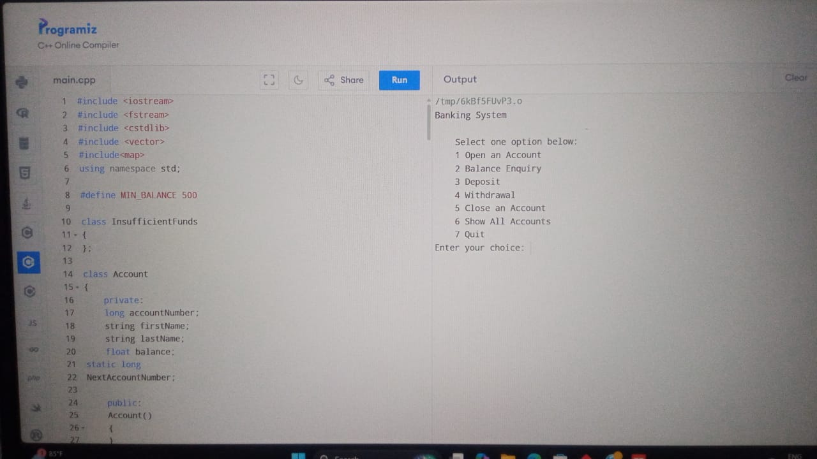

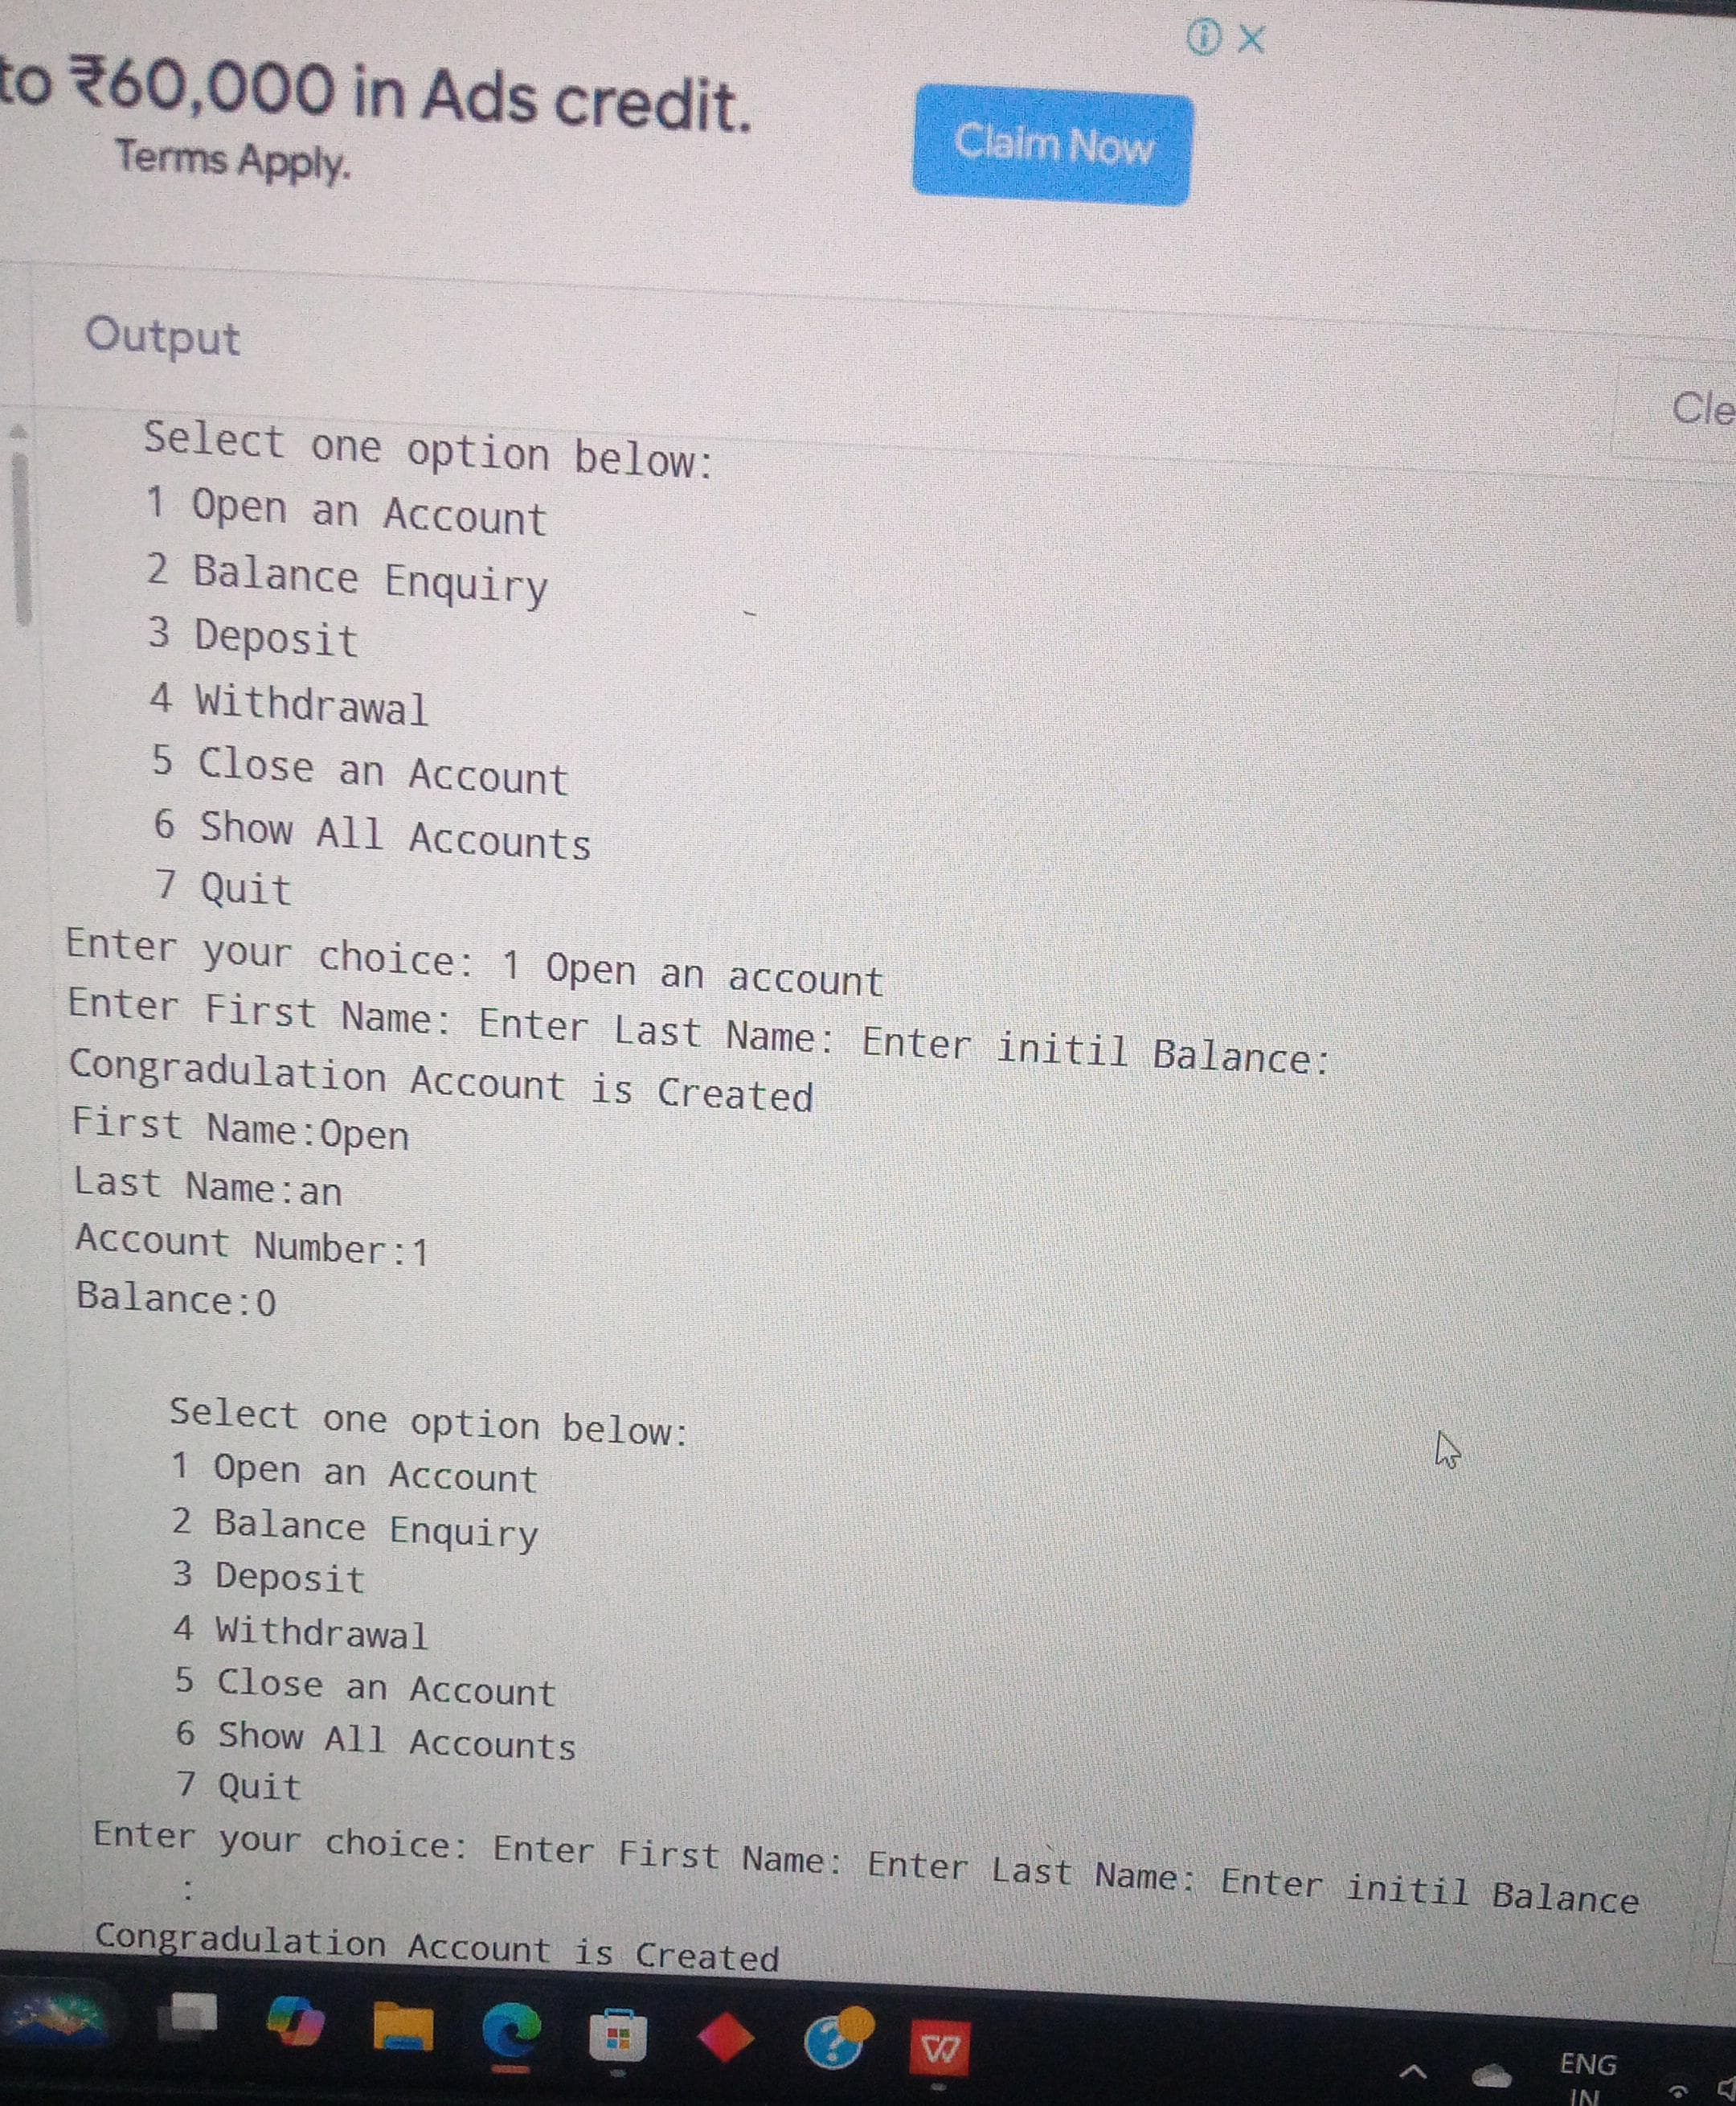

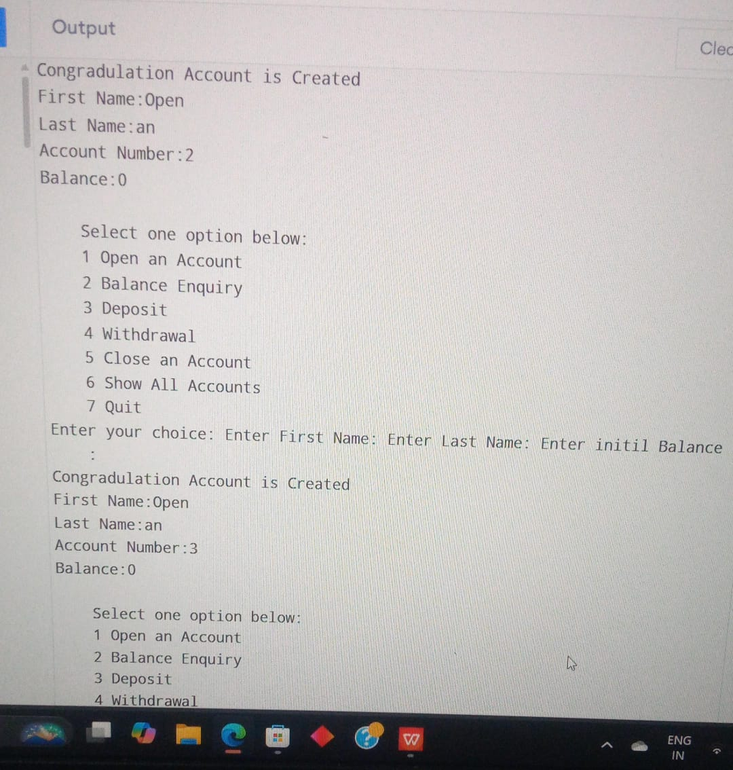

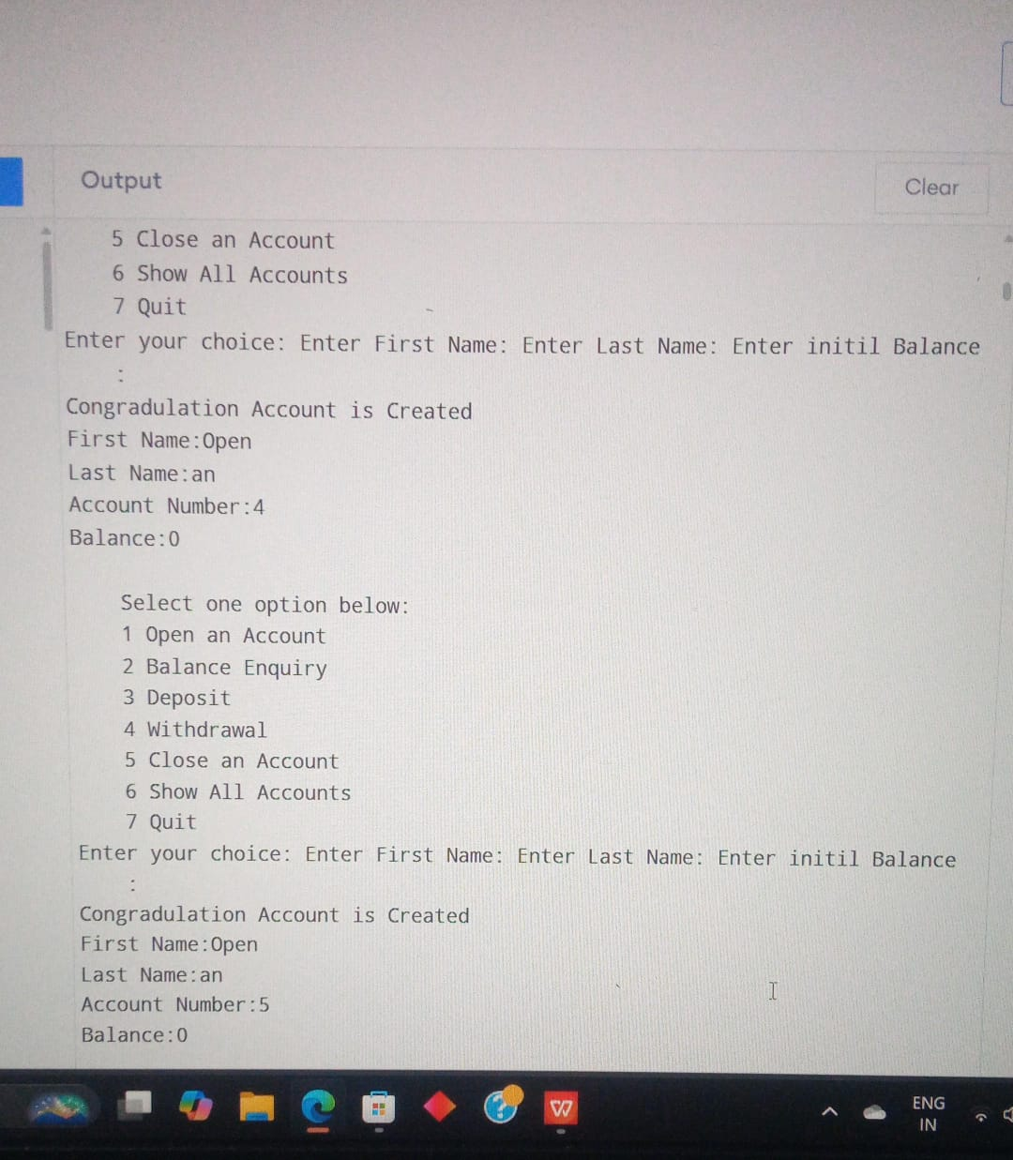

**CONCLUSION**

In conclusion a banking system developed in C++ offers several advantages due to the language's efficiency, object-oriented structure, and control over system resources.

A banking system in C++ is a robust, efficient, and flexible solution for managing banking operations, but it requires careful design and maintenance to ensure data security, scalability, and performance.